NETSTAT

# Using NETSTAT

# 1. All “Executables” involved in creating the connections.

Cmd: netstat -b

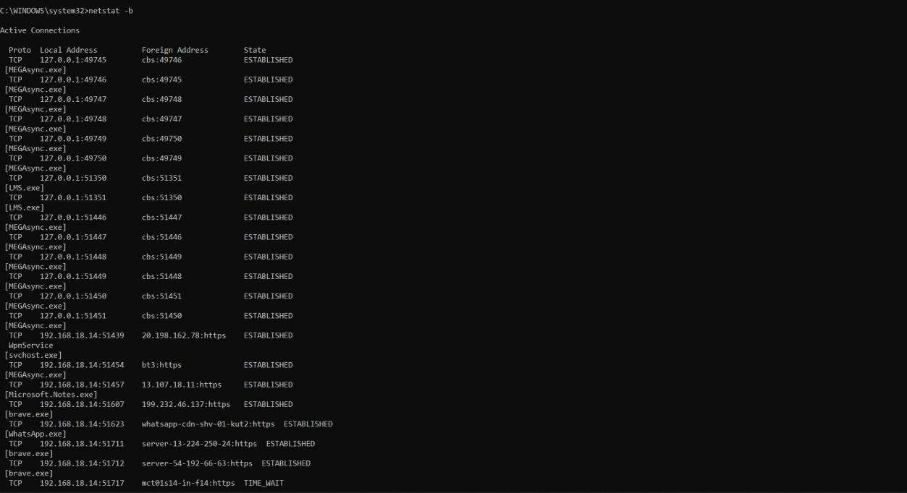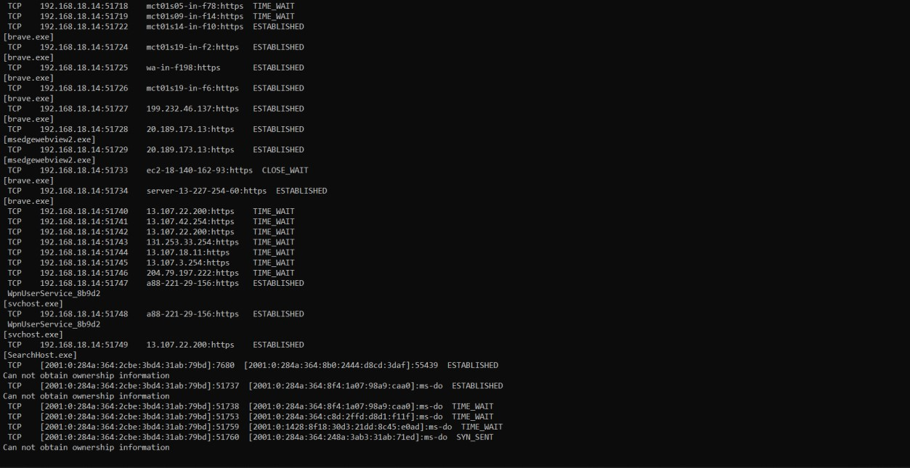

# 2. The Fully Qualified Domain names

CMD: netstat -f

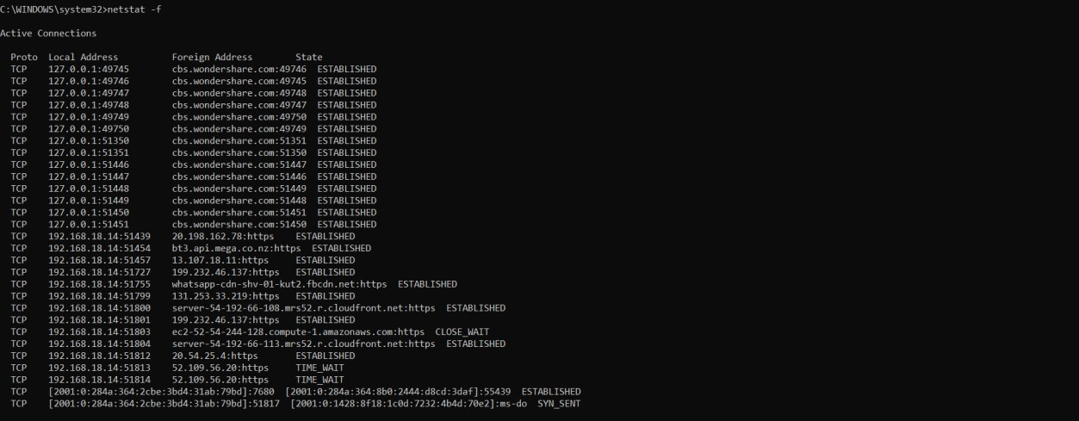

# 3. Connections specifically for TCP Protocol

CMD: netstat -p TCP

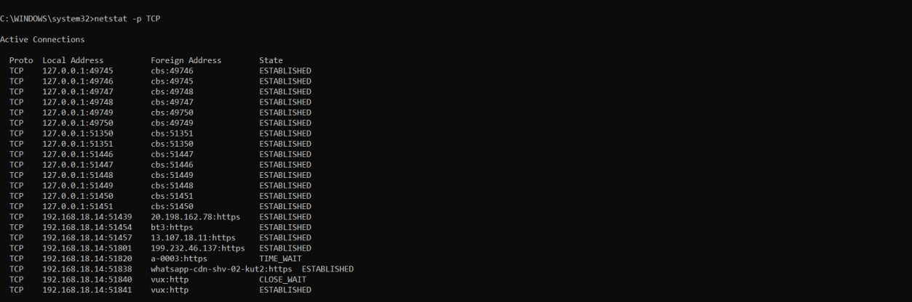

# 4. Connections specifically for UDP Protocol

CMD: netstat -p UDP



# 5. The routing table

CMD: netstat -r

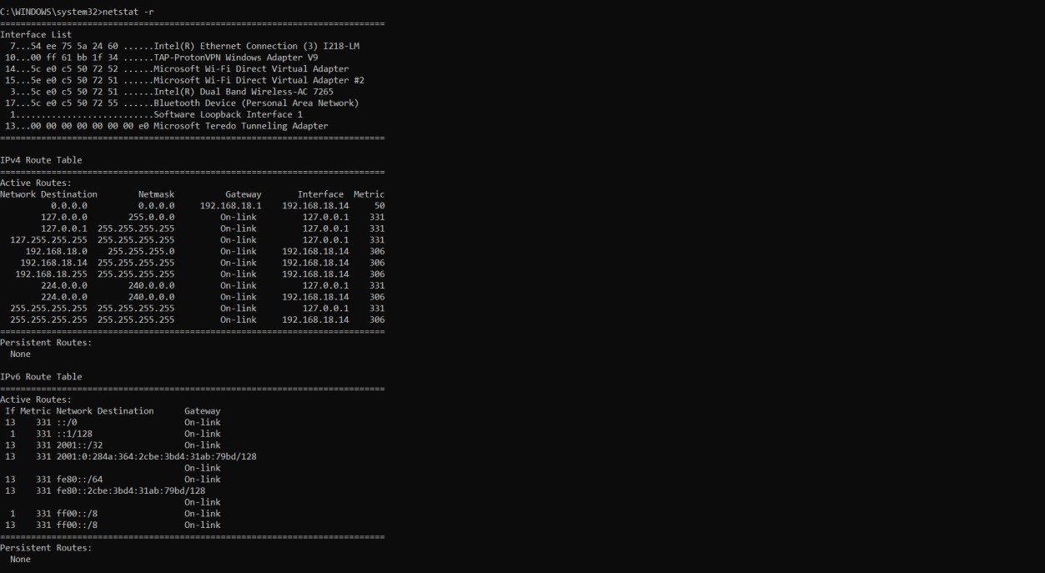

NET USER

## Using NET USER

# 1. Create a NEW USER.

CMD: net user NAME /add

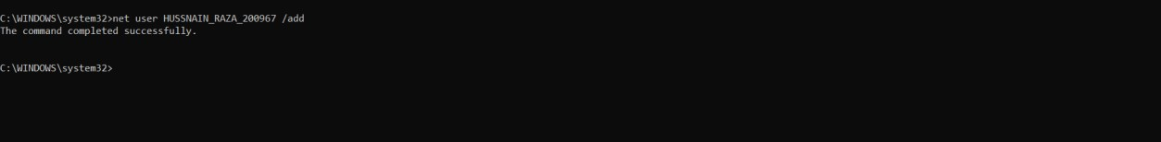

# 2. Assign the time of 10AM to 3PM for Monday to Wednesday.

CMD: net user FAHAD_MURAZA_201015 /times:M-W,10am-3pm



# 3. Create New localgroup:

CMD: net localgroup localgroup201015 /add



# 4. Add User to the newly created localgroup

CMD: net localgroup localgroup201015 FAHAD_MURAZA_201015 /add

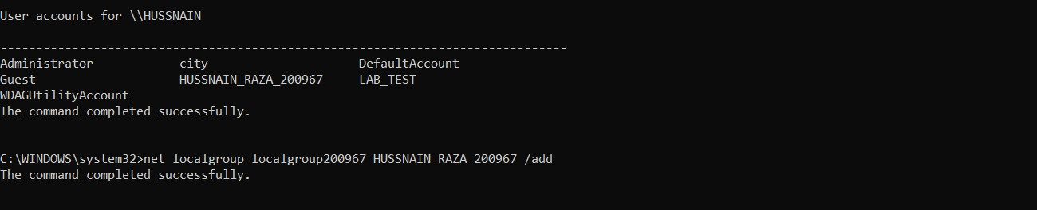

# 5. Display/View the information about the User

CMD: net user

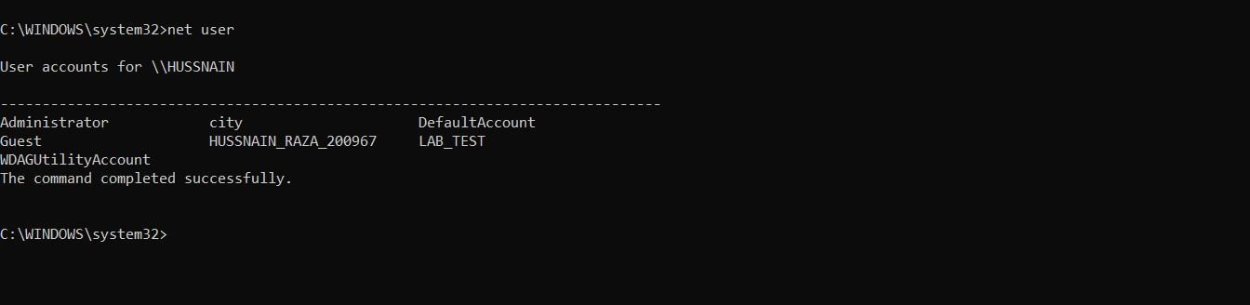

NET SHARE

## Using NET SHARE

# 1. Create a directory:

CMD: md D:FAHAD_201015



# 2. Create a NEW SHARE for this directory.

` CMD: net share FAHAD_201015=D:\



# 3. Assign the time of 10AM to 3PM for Monday to Wednesday.

CMD: net user FAHAD_MURAZA_201015 /times:M-W,10am-3pm



# 4. Create New localgroup:

CMD: net localgroup localgroup201015 /add



# 5. Add User to the newly created localgroup

CMD: net localgroup localgroup201015 FAHAD_MURAZA_201015 /add



# 6. Display/View the information about the User

CMD: net user

